Map Routing [**Test Cases Description]**

Contents

FIRST: Sample Cases 2

SECOND: Medium Cases 3

THIRD: Large Cases 3

(BONUS) Maps with changing speed 5

Input & Output Description 6

# FIRST: Sample Cases

|  |  |  |  |  |  |  |
| --- | --- | --- | --- | --- | --- | --- |
| Map File Name | Queries File Name | Output File Name | # intersections | # Roads | # queries | Total Execution Time for all queries |
| map1.txt | queries1.txt | output1.txt | 6 | 7 | 1 | < 1 sec |
| map2.txt | queries2.txt | output2.txt | 6 | 7 | 10 | < 1 sec |
| map3.txt | queries3.txt | output3.txt | 9 | 12 | 10 | < 1 sec |
| map4.txt | queries4.txt | output4.txt | 9 | 8 | 10 | < 1 sec |
| map5.txt | queries5.txt | output5.txt | 9 | 8 | 10 | < 1 sec |

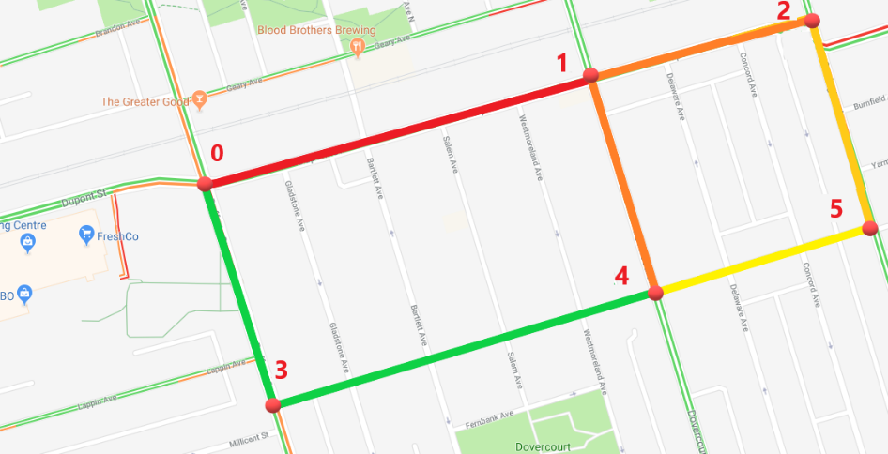

Figure 1 The road network used in the first 2 sample files

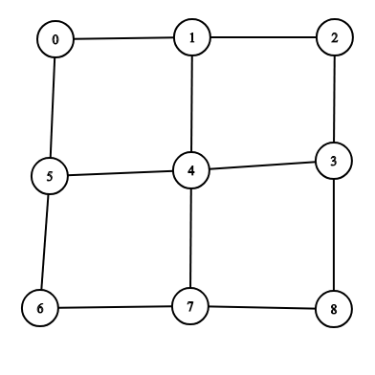

Figure 2 The road network used in sample 3

# SECOND: Medium Cases

The data of the medium case is for Oldenburg road network (Oldenburg is a German city)

|  |  |  |  |  |  |  |
| --- | --- | --- | --- | --- | --- | --- |
| Map File Name | Queries File Name | Output File Name | # intersections | # Roads | # queries | Total Execution Time for all queries |
| OLMap.txt | OLQueries.txt | OLOutput.txt | 6105 | 7029 | 1000 | < 5 sec |

# A close up of a map Description generated with high confidenceTHIRD: Large Cases

Figure 3 the city of Oldenburg road network

The data of the large case is for San Francisco Road Network

|  |  |  |  |  |  |  |
| --- | --- | --- | --- | --- | --- | --- |
| Map File Name | Queries File Name | Output File Name | # intersections | # Roads | # queries | Total Execution Time for all queries |
| SFMap.txt | SFQueries.txt | SFOutput.txt | 174956 | 221802 | 1000 | < 3 min |

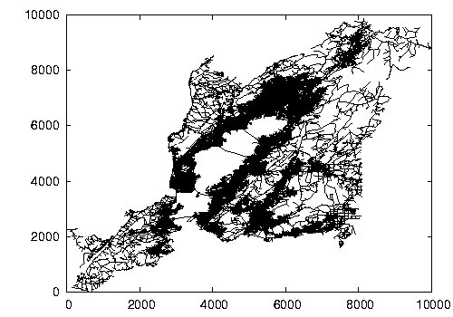

Figure 4 San Francisco road network

# (BONUS) Maps with changing speed

In this scenario, road speed is not constant anymore. The speed changes depending on the time interval. You should consider the speed changing when finding the path with the shortest time.

For the following example:

* The speed interval is **10** minutes, each road has 2 speeds (speed count = 2).
* The **road length** from intersection **0** to intersection **1** is **20 km**. This road (from 0 to 1) has speeds **[80 km/h, 60 km/h]**.
* The road length from intersection **1** to intersection **2** is **10 km**. This road (from 1 to 2) has speeds **[30 km/h, 50 km/h].**
* The vehicle speed doesn’t change in the middle of the road (even if the time interval changes).
* At the start of time (time = 0), the vehicle moves from intersection 0 to intersection 1. It will move with speed 80 km/h for the whole road (even if it exceeds the speed interval, speed doesn’t change in the middle of the road).
* When the vehicle reaches intersection 1 (at time = 15 minutes), It would move from intersection 1 to intersection 2 with the speed of the second interval for that road (50 km/h).
* The time to move from intersection 0 to intersection 2 = 15 + 12 = 27 minutes.

**10 km**

**20 km**

## Input & Output Description

* The map file for this scenario will consist of the following:

1. The first line contains an integer **N** which represents the **number of intersections**.
2. Each line of the following N lines contains 3 numbers (separated by single space):

**Intersection_ID** **X_coordinate** **Y_coordinate**

1. After that there is three integers (separated by single space):

**M** **Speed_Count**  **Speed_Interval**

Where **M** represents the **number of roads**.

**Speed_Count** represents the number of speeds of each road, and

**Speed_Interval** represents the interval of speed changing **(in minutes)**.

1. Each line of the following M lines contains (**3 + Speed_Count)** numbers (separated by single space):

**First_Intersection_ID** **Second_Intersection_ID** **Road_Length** **Road_Speed1  Road_Speed2 , ….., Road_SpeedSpeed_Count .**

This means that this road speed is **Road_Speed1** in the interval **[0, Speed_Interval)**,

It will be **Road_Speed2** in the interval **[Speed_Interval, 2 x Speed_Interval)**

and so on..

Note : the road length is given in **kilometers** and road speeds are given in **kilometer/hour**.

* The query file is in the same format as the normal case (constant speed).
* The output file should be in the same format as the normal case.

**Note:**

* The speeds repeat if the time exceeds the speed count. For example:
* The road from intersection 0 to intersection 1 in the previous figure will have the speeds 80 km/h in the interval [0, 10), then the speed becomes 60 km/h in the interval [10, 20), then it becomes 80 km/h in the interval [20, 30), and so on…